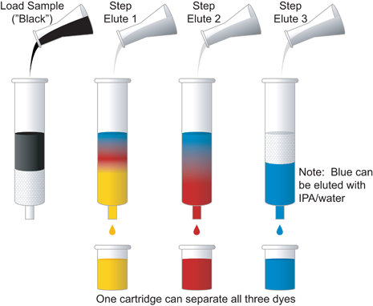
Column Chromatography Demo

Materials Needed:

Sep-Pak® C18 cartridge 25 % Isopropyl alcohol sol., 10 mL
Syringe, 10-mL 5% Isopropyl alcohol sol., 10 mL
Grape Kool-Aid® sol., 1 mL Distilled water, 10 mL
70% Isopropyl alcohol sol., 20 mL 3 cups
Steps:
- 10mL 70% isopropyl alcohol in syringe
- Attach long end of Sep-Pak® cartridge to syringe tip
- pump alcohol at 5-10 mL/min into cup
- draw 10 mL DiH2O
- Attach long end of Sep-Pak®
- pump DiH2O at 5-10 mL/min
- 1 mL grape Kool-Aid® into syringe
- pump Kool-Aid®
- Draw 10 mL of 5% alcohol & pump into separate cup – elutes red dye
- Draw 10 mL of 25% alcohol & pump into separate cup – elutes blue dye
- Flush 10 mL of 70 % alcohol to clean Sep-Pak® cartridge.

Chromatography is - an analytical separation method used to separate, isolate, and
purify organic and biological compounds based on differences in
polarity, size, or charge.
- a common method used to identify components in a mixture.

Chromatography attributes - Most chromatography is based on the differences of a molecule’s
solubility in two phases.
- Solubility is based on the polarity of the molecule versus the polarity of the phases.
- “like dissolves like” adage
- In adsorption chromatography there are two phases, a stationary phase and the mobile phase. The stationary phase, sometimes called the adsorbent, is a porous material that will attract and adsorb the components of the mixture. The mobile phase, also called the solvent or eluent, will wash and carry the components of a mixture through the stationary phase.
- Chromatography works on the concept that the compounds in the mixture are slightly soluble in the mobile phase and will spend some of their time on the stationary phase and some of their time in the mobile phase. Each component in a mixture will have a different affinity for each phase.

Major types of chromatography:
- paper chromatography
- Thin-layer chromatography (TLC)
- Column chromatography
- Gas chromatography (GC)
- High-pressure or high performance liquid chromatography (HPLC)

